# **Lab 5. Research on DC drive PWM converters**

Student name: _________Li Xin__________

Date of submission______2025.4.9_______ HDU ID ________22320404___________ Student ITMO ID____375334__________

## Part 1. Evaluate missing parameters

* Open Actuators_Lab_5_R2022b.slx model and Actuators_Lab5_R20XX.mlx
* Source data

=75 - Rated source voltage, V;

=600 - Rated rotating speed, rpm;

= 1.21e+03 - PWM frequency, Hz;

=0.075 - Resistance of DC machine winding, Ω;

=5.54e-04 - Armature inductance, H;

=0.238 - Moment of inertia, ;

50 - Anchor rated current of DC machine, A;

1.8 - Maximum current limit, A.

Evaluations:

- Power, W;

1000 - Short circuit current, A;

62.8319 - Rated rotating speed, rad/s;

1.134 - EMF constant, V*s/rad;

- Electromechanical constant, /A;

56.69 - Rated Torque of the DC machine, ;

102.0581 - Maximum torque, ;

1.13e+03 - Starting torque, ;

- Rated efficiency, %;

0.0074 - Electromagnetic time constant, s;

66.1388 - Idle speed, rad/s;

0.0139 - Electromechanical time constant, s

## Part 2. Evaluate parameters of the system with PWM

**Transistor switched on circuit parameters**

= 0 - IGBT Forward voltage at current , [V] (For MOSFET may be considered equal to 0);

= 1.2 - Forward voltage at current

, [V];

= =0.0133 - MOSFET / IGBT resistance , [Ω];

**Snubber circuit parameters**

= 330e-9 - Snubber capacitance, [F];

= 1e6 - Snubber resistance, [Ω];

**Reverse (antiparallel) diode parameters**

= 0.85 - Internal (antiparallel) diode forward voltage at current  
 , [V];

= 0.95 - Internal (antiparallel) diode forward voltage at current   
 , [V];

= 0.0011 - Internal (antiparallel) diode resistance , [Ω];

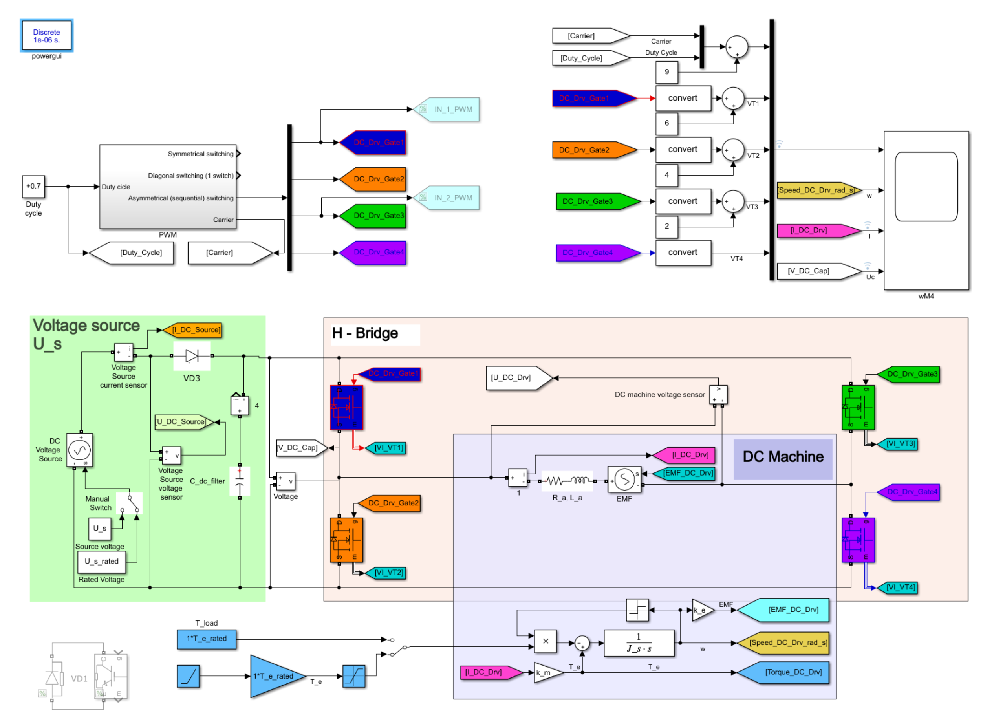

Figure 1 – DC drive system under test

## Part 3. Simulation results

NB! Duty cycles values are in your variant data: as *gamma_all* values.

[1; 0.75; 0.5; 0.1]

* Compare diagonal (one switch) and symmetric switching

|  |
| --- |
|  |
| a)symmetric |
|  |
| b) asymmetric sequential |
|  |
| **с) Diagonal** this is example! Replace it if your own simulation result! |

Figure 2 – DC drive mechanical characteristics

**NB! with new parameters your result will be slightly different!**

## Part 4. Simulation results

* **Analyze drive parameters with different pulse width with duty cycle gamma= 0.75 and T_load=**

|  |  |  |
| --- | --- | --- |
| **Symmetric** | **Diagonal** | **Asymmetric sequential** |
|  |  |  |
| PWM diagram | PWM diagram | PWM diagram |
|  |  |  |
| DC Voltage U_s [V] | DC Voltage U_s [V] | DC Voltage U_s [V] |
|  |  |  |
| DC machine current I_a [A] | DC machine current I_a [A] | DC machine current I_a [A] |
|  |  |  |
| DC machine speed ω [rad/s] | DC machine speed ω [rad/s] | DC machine speed ω [rad/s] |
|  |  |  |
| Converter efficiency | Converter efficiency | Converter efficiency |
|  |  |  |
| DC drive efficiency | DC drive efficiency | DC drive efficiency |
|  |  |  |
| Total efficiency | Total efficiency | Total efficiency |

**EXAMPLE:**

|  |  |  |
| --- | --- | --- |
| **Symmetric 3** | **Diagonal 2** | **Asymmetric sequential 1** |
|  |  |  |
| PWM diagram | PWM diagram | PWM diagram |
| Us | Us | Us |
| DC Voltage U_s [V] | DC Voltage U_s [V] | DC Voltage U_s [V] |
| I | I | I |
| DC machine current I_a [A] | DC machine current I_a [A] | DC machine current I_a [A] |
| w | w | w |
| DC machine speed ω [rad/s] | DC machine speed ω [rad/s] | DC machine speed ω [rad/s] |
| Ce | convert | convert |
| Converter efficiency | Converter efficiency | Converter efficiency |
| DC | DC | DC |
| DC drive efficiency | DC drive efficiency | DC drive efficiency |
| Total | **Total** | **Total** |
| Total efficiency | Total efficiency | Total efficiency |
|  |  |  |

Figure 3 – DC Drive with PWM converter efficiency

Optimal switching frequency evaluation (symmetrical switching)

1.54e+03 Hz

Optimal switching frequency evaluation (non-symmetrical sequentional and diagonal switching)

= 1.21e+03 Hz

* **Analyze drive parameters with different pulse width with**
* **duty cycle (gamma)= 0.75 and T_load=**

Conclusions

Results of comparison efficiency, current and speed ripple in case of symmetrical, diagonal, and sequential switching.